Michael Eisner

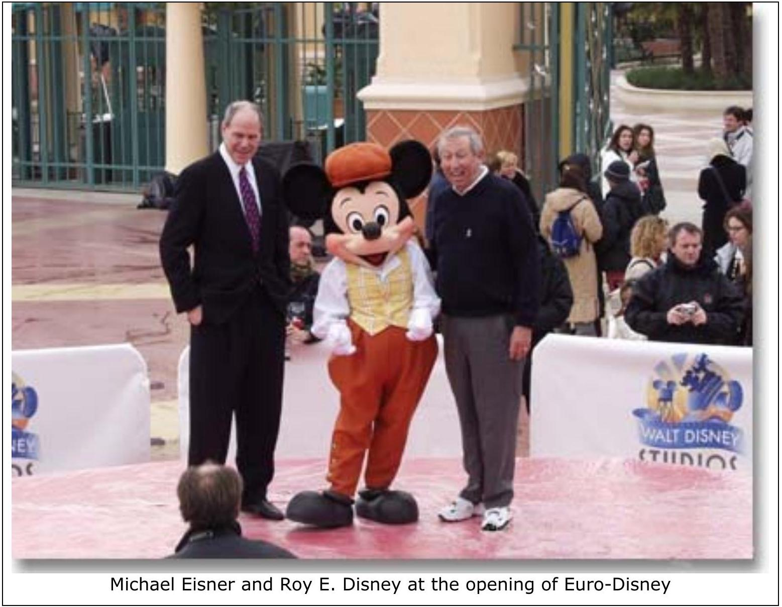

Michael Dammann Eisner was born in Mt. Kisco, New York, in 1942. His father, Lester, was a lawyer who served as administrator of the Department of Housing and Urban Development. His mother, Margaret, was a business executive: she co-founded the American Safety Razor Company and headed a medical research institute. He received a B.A. in English Literature and Theater Arts from Denison University, Ohio, in 1964.
Michael Eisner began his career at NBC Studios as an FTC logging clerk. Two months later, he took a job at CBS, planning the timing of commercials in children's shows. Looking for a better job, he mass-mailed his bio and received one reply. Barry Diller, head of programming at ABC, hired him as an assistant. (Diller, one month older than Eisner, was also just starting his career at ABC.) At ABC, Eisner hit his stride, receiving promotions every few years: Manager of Specials and Talent in 1967, Program Director for the East Coast in 1968, VP of Daytime Programming in 1971, VP for Program Planning and Development in 1975, and Senior VP for Prime Time TV Production and Development in 1976. The shows he developed included Happy Days, Barney Miller, and Starsky and Hutch.
Barry Diller also advanced at ABC, moving up on the motion picture side of the house. In 1969, he became VP in charge of motion picture development. His innovation was the made-for-TV movies; the miniseries "Roots" was one of his projects. In 1974, Diller moved from ABC to Paramount Pictures, where he became Chairman.
In 1976, Barry Diller hired Eisner as President and CEO of Paramount Pictures. At Paramount, Eisner and Diller had a dramatic impact. During Eisner's tenure, Paramount moved from last to first place among the big six studios. Whereas the average motion picture produced in Hollywood cost $1.2 million, the average Paramount production cost $8.5 million. During Eisner's tenure, Paramount produced Raiders of the Lost Ark, Saturday Night Fever, Grease, Heaven Can Wait, Ordinary People, Terms of Endearment, An Officer and a Gentleman, The Elephant Man, Reds, Flashdance, Footloose, Trading Places, Beverly Hills Cop, Airplane, and the first three Star Trek films.

The Walt Disney Company
Walter Elias Disney returned from service with the Red Cross in World War I, at the age of 17, with the determination to become an artist. After several failed attempts at cartooning, he and his brother Roy founded the Disney Brothers Studio in Hollywood in 1923. His first animated short, Oswald the Lucky Rabbit, was a hit, but he hadn't read the fine print in his distribution contract-the copyright to the character was lost to his distributor, who then hired away his animators. Disney quickly reimagined the rabbit as a large-eared mouse and named it Mickey. There was little interest in this new character until Disney added sound to the film-a first for a cartoon. With sound, Mickey Mouse became an international hit, and the Disney Company was on its way.
Walt Disney ventured into full-length feature films in 1937 with Snow White and the Seven Dwarfs. The film's success led Disney to plan to release two full-length color animated features each year. However, the company made no new feature films during World War II and, due to organizational and financial difficulties, did not do so until 1950. In 1950, Disney launched three key initiatives: (1) a new full-length cartoon (Cinderella) was released, (2) Disney's first non-cartoon feature (Treasure Island) was released, and (3) the company's first TV foray (One Hour in Wonderland) reached twice as many viewers as there were TV sets. Unlike other movie studios, Disney did not pay top fees to performing artists. The "mouse" worked for nothing, and Disney movies were made with the studio's own talent. The same pattern was followed in television, where the popular show Disneyland showcased the construction of the company's theme park, and the Mickey Mouse Club used child hosts to showcase other Disney products.
Disneyland was a great risk for the company, but it turned out to be a success. Walt began secretly buying land in Florida for an even larger park, but died in 1966, before the project could be started.
Walt's brother Roy oversaw Disney World, which became the most successful park in the world. He died in 1971, passing the family's management interest to his son, Roy E. Disney. Despite the construction of a new Disneyland in Tokyo, the company's financial performance began to sag in the 1980s. Both feature films and cable TV operations were bringing in little profit. Corporate raiders began to circle, seeing an opportunity to split the company into its components and make a quick gain. As Saul Steinberg and Irwin Jacobs prepared a takeover, the Bass brothers (Texas oil wealth) acted as a "white knight," protecting the company from hostile bids. In October 1984, the Bass interests put Roy E. Disney back on the board of directors and hired Michael Eisner as chairman and CEO. At the same time, Frank Wells was named president and chief operating officer. Wells had been vice-chairman of Warner Brothers and had a background in law and management.

Turning Around Disney
Eisner's first move was to bring in two executives he knew from Paramount, Jeffrey Katzenberg and Richard Frank, to run the motion pictures and television operations, respectively. Katzenberg had started as Diller's assistant at Paramount and had risen to head up production at the studio.
The turnaround at Disney engineered by Eisner and Wells was remarkable. Profits from films and television soared. Even more importantly, the creative heart of the company-the animated feature film-was recharged, and a host of new characters was created. Each new character, or property, generated profits far beyond the film. Toys, games, TV specials, Disneyland rides, and other synergies were carefully exploited.
Michael Ruckstad and David Collis, "The Walt Disney Company: The Entertainment King," Harvard Business School case 9-701-035, 2001.
One of the new management's top priorities was to rebuild Disney's TV and movie business. Disney had stopped producing shows for network television out of concern that it would reduce demand for the recently launched Disney Channel. But Eisner and Wells believed that a network show would help create demand by highlighting Disney's renewed commitment to quality programming. In early 1986, The Disney Sunday Movie premiered on ABC.
According to Eisner, the show "helped to demonstrate that Disney could be inventive and contemporary.... It put us back on the map." $_{29}$ During this time, Disney produced the NBC hit sitcom Golden Girls, the popular Saturday-morning cartoon Disney's Adventures of Gummi Bears, and the syndicated non-network shows Siskel & Ebert at the Movies and Live with Regis & Kathie Lee. Eisner also created a syndication operation to sell to independent TV stations some of the TV programming that Disney had accumulated over 30 years.
Disney's movie division was nearly as moribund when Eisner and Wells took over. Disney's share of box office had fallen to $4\%$ in 1984, lowest among the major studios, and Eisner contended that not one of the live-action movies that Disney had in development seemed worth making.
In the mid-1980s, Disney’s turnaround was not a product of vague "vision" but of coherent action: Disney diagnosed a Hollywood market bloated by overpriced stars and inefficient production cycles and responded with a strategy of resource leverage. By targeting underpriced assets—actors in career slumps and lesser-known writers—they prioritized script integrity over celebrity ego. This discipline allowed them to industrialize their creative output, scaling from two films a year to a high-velocity slate of 15–18 releases. This was not merely about cost-cutting; it was a deliberate choice to dominate the mid-budget comedy and wholesome live-action segments, where they could maintain a high "strike rate" of profitability.
Disney didn’t just shorten the animation cycle from five years to 18 months via technological investments like CAPS; they ensured every creative "hit" functioned as a force multiplier across the entire corporate ecosystem. A flagship project like Who Framed Roger Rabbit served as the anchor for a massive secondary economy of over 500 products and global promotional tie-ins. By 1988, this alignment of tight budgetary control, high-volume production, and aggressive cross-merchandising transformed Disney from a "nerdy outcast" into the market leader with a 19% share of the U.S. box office.
John Huey, "Eisner Explains Everything," Fortune, April 17, 1995
No one disputes Eisner's dazzling ten-year report card: In 1984 the dilapidated company that he and his partner, the late Frank Wells, took charge of depended on the cyclical theme-park business for almost $80\%$ of its operating income and on movies for only $1\%$. Eisner's revived Disney earns $43\%$ of its income from movies and only $35\%$ from theme parks. The old Disney brought in less than $9\%$ of its revenues from overseas; today's Disney, $23\%$. The old Disney dabbled in the resort business, with 2,894 hotel rooms; the new Disney offers 21,586 rooms at 21 resorts, is building more all the time, and is headed pell-mell into the cruise ship business.
Also indisputable: With one recent interruption-for the financial debacle at Euro Disney-Eisner has given shareholders a great ride. Disney has consistently reported annual increases in profits and return on equity of more than 20%, and Wall Street has rewarded it by driving its market value up from less than $2 billion in 1984 to more than $28 billion today—bigger than Ford, for example. Meanwhile, Eisner's pay—while keeping him far below Gates' billionaire status-has been directly linked to the company's performance and, thus, damned good. In his decade at Disney he has pulled down some $\$300$ million before taxes, much of it in stock that increased some 15-fold under his management. He's also still sitting on 10.9 million shares, worth roughly $\$600$ million pretax. What's more, Eisner's enviable record has afforded him a sovereignty as CEO that is the elite province of only a few corporate chieftains-say, GE's Jack Welch or Coca-Cola's Roberto Goizueta. 'The board doesn't control Disney, and the investors don't control it,' says Barry Diller, his friend, ex-boss, and possible partner in buying a network. 'Michael controls it.'

The Katzenberg Affair
On April 3, 1994, Frank Wells was killed in a helicopter crash. Eisner and Wells had developed a very close working relationship, each balancing and complementing the other. Eisner said "Frank was so rare. And we had trust. If you look at the difference between him and others, who I am not going to talk about...I could say anything to Frank about the way I felt. I knew that if we were going to get in trouble, we were going to be in trouble together. I wasn't going to take the rap, and he wasn't going to take the rap. We would take the rap-together."
In July of 1994, Eisner underwent an emergency quadruple-bypass operation. He recovered quickly and his experience under the knife seemed, if anything, to toughen him. "I have less patience for betrayal than I had.... I deal with a broad range of talent, and if the talent is really there, I will put up with a lot. But there is a whole level of maybe not real talented people who really test you. I am less patient with that group now. And I am a little more confident today to go with what I think is right and wrong."
Within a year, several key executives left Disney and new executive talent was brought in. Most notably, Jeffrey Katzenberg had hoped to replace Frank Wells as president of Disney, but Eisner did not want him to have the job. Annoyed, Katzenberg left Disney to work with Steven Spielberg and David Geffen to form Dreamworks. At Disney, Katzenberg had been the ramrod behind Roger Rabbit, Beauty and the Beast, Aladdin, and the Lion King, as well as putting together such hits as Pretty Woman.
Describing the decision not to promote Katzenberg, Eisner said:
Jeffrey wanted a job I was not prepared to give him.... So he left the company. That is what happened. I feel badly that it turned into an emotional thing, which I am trying to stay away from, but for our company in the next decade I did not feel that he should be president-for a lot of very logical reasons and also for some intuitional reasons. It was a hard decision, and I didn't make it in one day, and I didn't make it lying in the hospital. Jeffrey wanted to be completely in the spotlight, and he was no longer interested in the team unless he was the captain. I think he was shocked I felt that way, but I believe we had enough information over and over again that he should not have the job. He did not want to admit that was the case.
Katzenberg brought suit against Disney, claiming he had been promised promotion and more. He settled in 1999 for an undisclosed sum (rumored to be $\$250$ million.)

CapCities/ABC
In mid-1995, Disney announced it would buy CapCities/ABC to gain access to a programming distribution channel. At $19 billion, the deal was then the second-largest in corporate history and was executed without investment bankers and in absolute secrecy. Wall Street analysts praised the potential for synergy and the "access" ABC created for Disney products.t.

The Disney Structure and Culture
Unlike many entertainment companies, Disney was known for hiring professional managers and maintaining a strong management culture. This relatively centralized system ran counter to the personality-driven organizations in many other media-based firms.
Frank Rose, "The Disney School of Business, Fortune, July 6, 1998
The Disney system pits strong division managers against a strategic-planning unit that acts as a check on their power. Put in place by the late Frank Wells, Disney's president until his death in a 1994 helicopter crash, and former CFO Gary Wilson, now chairman of Northwest Airlines, it also fosters a high degree of centralization. The key is the strategic planning department, which mirrors the rest of the company, with its operatives assigned to a business unit and reporting back to their chief, who in turn reports to Eisner. Conflict is built in, because that's the way Eisner likes it.
"Michael will sit in on a meeting and listen to both sides," says one departed exec. "His feeling is that you put a lot of smart people in a room and listen to them duke it out, and the best idea will pop out--and it does." "You always have to fight your colleagues to show your worth," says another. "It's that Team Disney/court-of-the-Sun-King thing."
Despite the strong central direction, Eisner placed great emphasis on achieving synergy among the company's operating divisions. Again, unlike most media companies, Disney sought to institutionalize a culture of cooperation rather than simply relying on senior managers to coordinate activities.
Suzy Wetlaufer, "Commen Sense and Conflict: An Interview with Disney's Michael Eisner, Harverd Business Review, Jan-Feb, 2000.
You'd have to live in a cave to miss a new Disney movie coming out, what with the cross-promotions on TV, on the Web, at the theme parks, at the Disney stores, and even at McDonald's, with little Disney characters tucked in with the burgers and fries. What goes on inside Disney to make the blitz happen on the outside?
First and foremost, it's Disney Dimensions, which is a program we run two or three times a year for 25 senior people from every division of the company worldwide. So far, 300 people have gone through it. It's like synergy boot camp.
The people go through eight days of meetings covering every aspect of the company. They spend four days in California: in Burbank at the company headquarters, in Glendale at Disney Imagineering, and in Anaheim at Disneyland. They play characters in the park. They hear how you cook 100,000 meals a day. They see how the beds are made at our hotels.
Then they spend three hours at Disney Video. They do four hours at Interactive. They spend time with the legal department, with corporate finance. They spend time with human resources to understand the values of the company. They have presentations from every division -animation, television production, computer services, research and development, consumer licensing, theatrical movie distribution - everything.
Then they come to New York and spend two days at ABC, ESPN, and all that. Then they go to Walt Disney World and review all our businesses there. They learn what it is like to work in 100-degree heat and $100\%$ humidity, to clean bathrooms, cut hedges, check out guests, and soothe tired children.
They start at 7:00 in the morning, and they work until 11:00 every night for eight straight days. There are no phone calls, and they're not allowed to do any "regular" business.
Believe me, everyone starts off dreading Disney Dimensions. We know that. But by the third day, they love it. By the end of the eighth day, they have totally bonded. They've learned to respect what tens of thousands of people do, and they've become close friends at the same time.
When they go back to their jobs, what happens is synergy, naturally. When you want the stores to promote Tarzan, instead of the head of animation for Tarzan calling me, and me calling the head of the Disney stores, what happens is the head of Tarzan calls the head of the stores directly. . . . .For synergy to happen, the CEO and senior management have to push for it constantly.
Despite Eisner's managerial systems and the powerful Disney brand, financial results were less impressive in the late 1990s than during the 1984-1995 period. In part, the problem was a changing world in which the "nice" Disney image had less and less appeal to a coarsened youth culture. In part, it simply had to do with, at long last, real competition for kids' entertainment-Nickelodeon, Pixar's animated films, DreamWorks' Shrek, PBS' Teletubbies, and Nintendo's Pokémon. In part, it was a clash of cultures brought on by the CapCities/ABC acquisition. And, in part, the problem was simply size. In 1999, Disney was a much larger organization with less room for dramatic growth. The world of entertainment was only so big.
Marc Gunther, "Eisner's Mousetrap," Fortune, September 6, 1999
What changed everything, of course, was Eisner's boldest stroke as CEO: his $\$19$ billion merger with Cap Cities. That deal, cheered at the time, still appears strategically sound--the idea was to marry Disney content with ABC's broadcast and cable distribution. The problem has been execution. While ESPN and other cable properties have grown, no unit of the company is as besieged as ABC . It will lose money this year for the first time in a decade, despite a fantastic advertising marketplace, because audiences are splintering and programming costs keep climbing.
(Disney agreed under competitive pressure to spend $\$9.2$ billion- -that's right, billion--for NFL rights for ABC and ESPN through 2008.) Operating income for the company's broadcasting segment, which includes ABC, its TV stations, $80\%$ of ESPN, the Disney Channel, ABC Radio, and stakes in Lifetime, A&E, the History Channel, and E! Entertainment, grew by just $3\%$ last year; it's down $18\%$ so far this year, mostly because of ABC. "I'd be the first to say the results of the ABC television network, particularly in prime time, have been disappointing since the merger," says Robert A. Iger, 48, the lifelong ABC executive who is chairman of ABC Inc. While Iger's bailiwick extends way beyond the network, he keeps a close watch on programming and told FORTUNE in 1997, "Prime time is my No. 1 priority." Since then, ABC 's ratings for its 18- to 49-year-old target demographic have fallen by another 13%, leaving the network No. 3, behind NBC and Fox. Oops.
Wait, it gets worse. Remember how the merger was supposed to marry content and distribution? That's not working well either.
Owning and broadcasting a hit, then selling the reruns, is the best way to make big money today in television. Just ask Rupert Murdoch, whose Twentieth Century Fox TV studio not only owns the biggest hits on Fox-The Simpsons, The X-Files, and Ally McBeal-but also produces The Practice and Dharma & Greg for ABC, as well as key shows for NBC, CBS, and the WB. By contrast, Disney's Touchstone Television production studio has failed to develop a primetime hit for ABC or anyone else since creating Home Improvement in 1991. Out of sheer frustration, Eisner last month merged the Touchstone studio into ABC; the idea is to save money and force the two units to cooperate. ...
Writing about the Disney culture is tricky because knowledgeable critics are unwilling to speak on the record; the company's just too powerful. But talk to enough people and you hear similar complaints. One persistent theme: Eisner insists on making too many decisions himself, which clogs the decision-making process. So do the roomfuls of strategic planners who analyze everything. A second complaint: Eisner's too tough.
Working with Disney is notoriously difficult, so much so that a group of partners, including Coca-Cola, AT&T, Delta, and Kodak, used to meet informally to trade tips on how to cope. ...
Finally, the critics say, the company has simply grown too big to be run from the top down. Eisner's approach worked for the old Disney, where the focus was on a single brand; he could gather a cadre of executives at his Monday lunches and get things done.
Now Disney must manage multiple brands in a world where speed counts and partnerships are vital. A respected exDisney executive told me, 'The company has changed and the world has changed, but Michael hasn't changed. Now he's got to change.' Eisner and his lieutenants bristle at the criticism from unnamed sources, and you can't blame them. Yes, they say, Disney is tough, but so are GE and Microsoft-which, by the way, lose lots of executives, too, because they have an abundance of talent.

John Huey, “Eisner Explains Everything,” Fortune, April 17, 1995.
Ibid.
Ibid.

